|  |
| --- |
|  |

**SOFTWARE DESIGN DOCUMENT FOR THE WORLD CUP ANALYZER**

**SUBMITTED IN PARTIAL FULFILLMENT OF REQUIREMENTS FOR THE RECESS SEMESTER 2018**

Contents

**1.** **Introduction** 3

1.1 Purpose 3

1.2 Scope 3

1.3 Definitions, Acronyms and Abbreviations 4

1.4 References 4

1.5 Overview 5

**2.** **System Overview** 5

2.1 System Characteristics 5

2.2 System Architecture 5

2.3 Infrastructure Services 6

a. Security 6

b. Error Handling and Debugging. 7

**3.** **System Context** 7

**4.** **System Design** 8

4.1 Design Method and Standards 8

4.2 Documentation Standards 8

4.3 Naming Conventions 9

4.4 Programming Standards 9

4.5 Software Development Tools 10

4.6 Outstanding Issues 10

4.7 Decomposition Description 10

**5.** **Component Description** 11

5.1 TEAM PERFORMANCE ANALYSIS 11

5.1.1 Type 11

5.1.2 Purpose 11

5.1.3 Function 12

5.1.4 Subordinates 12

5.1.5 Dependencies 12

5.1.6 Interfaces 12

5.1.7 Processing 14

5.1.8 Data 14

5.2 SEEDING OF TEAMS 14

5.2.1 Type 14

5.2.2 Purpose 14

5.2.3 Function 15

5.2.4 Subordinates 15

5.2.5 Dependencies 15

5.2.6 Interfaces 15

5.2.7 Processing 17

5.2.8 Data 18

5.3 VISUALISATION 18

5.3.1 Type 18

5.3.2 Purpose 18

5.3.3 Function 18

5.3.4 Subordinates 19

5.3.5 Interfaces 19

1. **Introduction**
   1. Purpose

This Software Design Document is a written description of the World Cup Analyzer that will give the development team (Group-6) overall guidance to the architecture of the project. It is detailed with narrative and graphical documentation including feature specifications to the smaller pieces.

* 1. Scope

The World Cup Analyzer is intended for all users interested in having insight on the World Cup tournament.

The software is available to be accessed via a website and can also be accessed by developers who wish to contribute or test via Github. No log in is required via the website. A user simply enters their team into a form and submits it after which information on how far the team can advance in the World Cup is returned. A user can also select a set of teams for seeding. When then selection is submitted, groups of teams according to the FIFA Rankings are returned.

The software, therefore, aims to determine the effectiveness of using FIFA Rankings of men’s national football teams in determining the results of the World Cup tournament through these functionalities.

However, it should be noted that using only the FIFA Rankings cannot possibly be as effective as it would have been had we taken into consideration other factors like strength of players, funding of individual teams, etc. which, at this point, we do not have the capacity to do.

* 1. Definitions, Acronyms and Abbreviations

World Cup Analyzer – this is the name given to the software we are developing.

FIFA – Federation Internationale de Football Association is the sports global governing body.

World Cup – officially known as the FIFA World Cup is an international association football competition for men’s national football teams of members of the FIFA. It is awarded every four years.

FIFA Rankings – officially known as the FIFA World Ranking, this is a ranking system for men’s national football teams of FIFA member states.

* 1. References

Concept Paper

This document proposes the idea of analyzing the FIFA world rankings to determine their effectiveness in predicting the eventual result of the tournament.

Author: Group-6

Version number: 2.0

Date: 24th June 2018

Location: ###

Software Requirements Specifications document

This document gives a detailed description of the requirements and functionalities of the **World Cup Analyzer**.

Author: Group-6

Date: 25th June 2018

Location: ####

018

Shawnhal

* 1. Overview

• Section 1 is the introduction and includes a description of the project, applicable and reference documents.

• Section 2 provides a system overview. This describes the system characteristics, system architecture, and infrastructure services.

• Section 3 contains the system context. This defines the external interfaces of the system.

• Section 4 describes the system design methods, standards and conventions.

• Section 5 contains the component descriptions.

• Section 6 includes the Requirements Traceability Matrix

1. **System Overview**

The World Cup Analyzer is a statistical model for determining the effectiveness of using the FIFA Rankings in predicting the results of the World Cup tournament. It is designed based on R programming language and it allows a user to enter a team and be able to find out how far it can go in the World Cup. It also enables the users seed teams that play in the world cup finals and have them put into groups according to their FIFA Rankings (seeding).

* 1. System Characteristics

The World Cup Analyzer operates in bursts, that is to say when a user submits the team or set of teams via the website, they have to wait for the information (prediction of how far it can go or seeded groups respectively) to be returned. The software is highly resilient and works even with errors. It can work with many users. The software is very secure because no user data is collected. All a user does is fill in a form on website with a team or set of teams. It is also highly scalable and is available on Github for any developer who has ideas to expand it. There are no special backup facilities needed since the project is safe on Github and can be accessed any time in case the website crashes.

* 1. System Architecture

The software will be accessed using basic two-tier client-server architecture. The client, a web browser will send a request to the web server after a user has submitted it via the form on the website, that will host our R program and will be able to return what is requested. The web browser can be accessed remotely on any user’s computer with an internet connection.



**Fig 2.1**: Conceptual Diagram

* 1. Infrastructure Services

1. Security

The World Cup Analyzer software is secure as it does not in any way collect user data. A user can check the World Cup Analyzer website whenever and be able to do team analysis, seeding, factor evaluation without any need to sign in anywhere. They can also access it through our repository on Github through their accounts on the platform.

1. Error Handling and Debugging.

Error handling of code for the system is through research for solutions on developer community websites, were we ask questions and answers are provided by other developers on the community sites. For the World Cup Analyzer stack overflow and stack exchange have been a great platform for helping in debugging our code.

1. **System Context**

The World Cup Analyzer has five interfaces namely; Home, Team Analysis, Team Seeding, Visualisations and Summary.

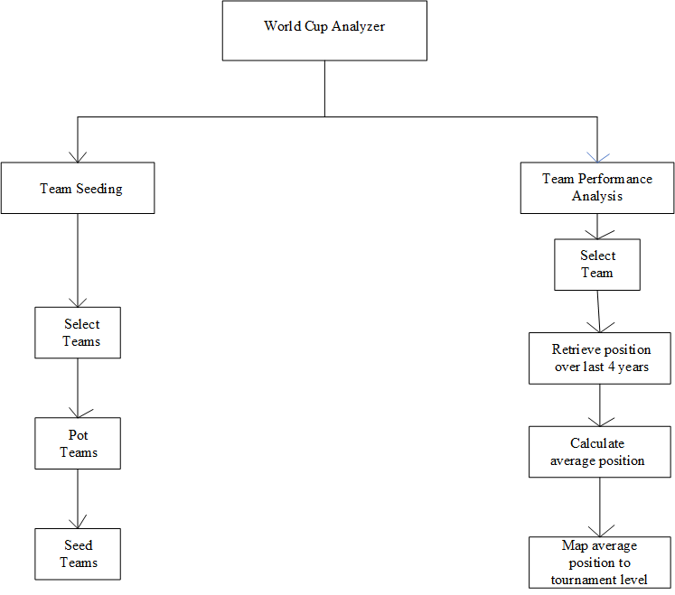

**Fig 3.1**: Functional Decomposition Diagram

The main functional requirements of the World Cup Analyzer are Team Seeding and Team Analysis which are described in detail in section 5 of this document.

The visualisations module is also an important one as it summarises the data in bar plots, histograms, maps and scatter plots. It is described in section 5.3 of this document with screenshots from the software.

The summary has the insights gained from the FIFA Rankings data set.

1. **System Design**
   1. Design Method and Standards

The design method used is the Model View Controller. Model View Controller is a software architecture – the structure of the system – that separates application logic from the rest of the user interface. It does this by separating the application into three parts: the model, the view and the controller.

The model manages fundamental behaviours and data of the application. It can respond to requests for information, respond to instructions to change the state of its information, and even to notify observers in event-driven systems when information changes. This could be a database, or any number of data structures or storage systems. In short, it is the data and the data-management of the application.

The view effectively provides the user interface element of the application. It’ll render data from the model into a form that is suitable for the user interface.

The controller receives user input and makes calls to model objects and the view to perform appropriate actions.

* 1. Documentation Standards

All documentation for the World Cup Analyzer software follows the IEEE standards and is typed in Times New Roman with a font size of 12 and 1.5 line spacing. The documents are all justified in alignment.

Where possible, aspects of the documentation are explained using UML diagrams in Visio for example data flow diagrams like use case diagram, functional decomposition diagram, context diagram et al.

* 1. Naming Conventions

|  |  |  |
| --- | --- | --- |
| Element | Text | Explanation |
| Title | World Cup Analyzer | This title clearly explains what our program undertakes i.e. analysing the World Cup Tournament. Users can therefore easily find and access it. |
| Version | V01 | This is the first version of this document and the software. |
| Date | 2018-04-07 | Date of release of this document. |
| Creator/Author | Group-6 | Group-6 created this document and designed the software as well. |
| Extension | .R  .csv | This is the file extension for program files written in the R programming language which is the language in which our program is written.  This is the file extension for the dataset to be worked with. |

* Dataset_name$variable_name; this is the format for writing variables in the R programming language.
* Comments are written with the # symbol preceding a statement meant to be a comment.
  1. Programming Standards

The World Cup Analyzer is a prediction and visualisation model designed in R programming language. The web-based features of the software are implemented using R shiny. The code for this project is stored on a Github repository with 4 contributors.

Commenting in the program is mainly be done on the functions in the language.

Indentation in RStudio is left-aligned throughout most of the program. The program begins with importing the dataset to work with and then the program modules as described above follow.

Our program will comprise of various functions in R such as the require function to call on the data, function arguments, dataset variables.

The packages installed for the smooth running of the World Cup Analyzer include; dplyr, DT, ggplot2, gridExtra, RColorBrewer, reshape2, rworldmap, shiny, shinydashboard etc.

* 1. Software Development Tools

The Software Development tools used are;

* RStudio
* R(Scripting language)
  1. Outstanding Issues

At the time of writing this document, Group-6 has not yet figured out how to evaluate factors used to come up with the FIFA Rankings. Group-6 figures that they may need more than the FIFA Rankings data set to do this effectively. These may include, results of matches, where and when the matches were played, strength of players, goals scored, etc. To include all these data sets in our model would make it more complex but also more accurate.

* 1. Decomposition Description

The major components of the World Cup Analyzer are described in section 5.



Fig 4.1: High level view of system components

1. **Component Description**
   1. TEAM PERFORMANCE ANALYSIS
      1. Type

Team analysis is a task that is done by the World Cup Analyzer software. It is one of the major system features.

The task contains data on all teams that take part in the FIFA World Cup and executable computer instructions.

* + 1. Purpose

The team performance analysis task is for predicting how far a team will go in the World Cup tournament and also give users an insight on how a team has been performing in the past 4 years, whether it has improved or declined.

* + 1. Function

When a user selects a team of their choice, the Team Performance Analysis task looks up the details of this team for the last 4 years as it is what FIFA bases on to do the Rankings, and they are displayed. A summary of the teams statistics is also displayed to give users an insight on how a team has been performing, whether it has been improving or declining.

* + 1. Subordinates

It therefore calls the FIFA Rankings.csv file and searches through it for the particular team. It also calls the visualisations module and scatter plots are displayed to show team position over the last four years and the team’s progress.

* + 1. Dependencies

For this task to be executed, a user must select a team first.

* + 1. Interfaces

When a user opens the World Cup Analyzer website, there is a home page where they can select the ‘Team Analysis’ option from.

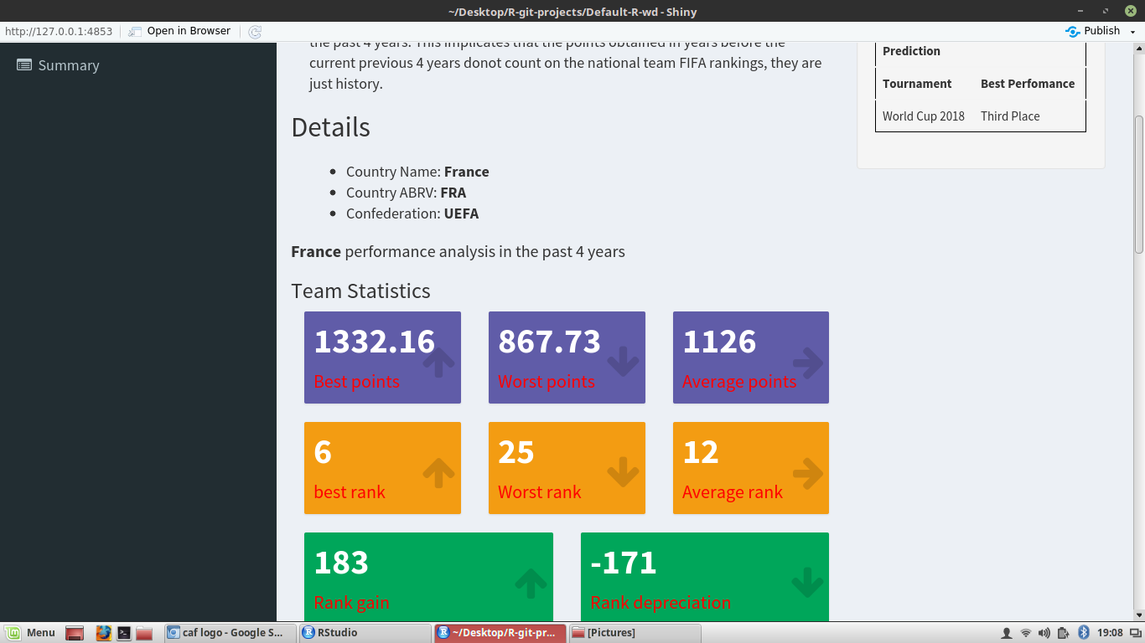

Once on the Team Analysis page, the user can select any team from the drop-down menu option and submit.

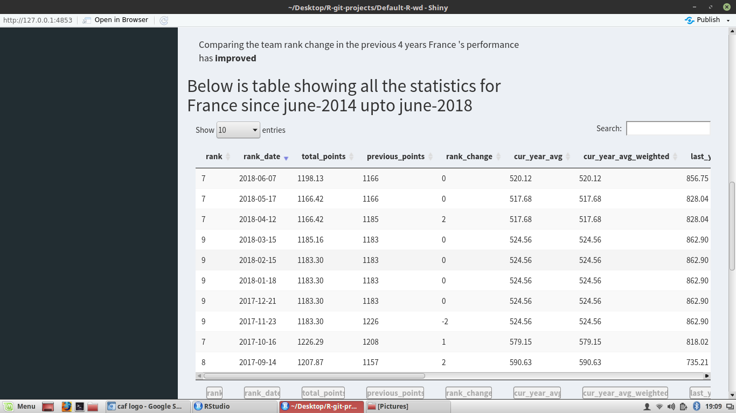

It returns the team’s positions for the last four years and scatter plots of the same with a summary of the team statistics.

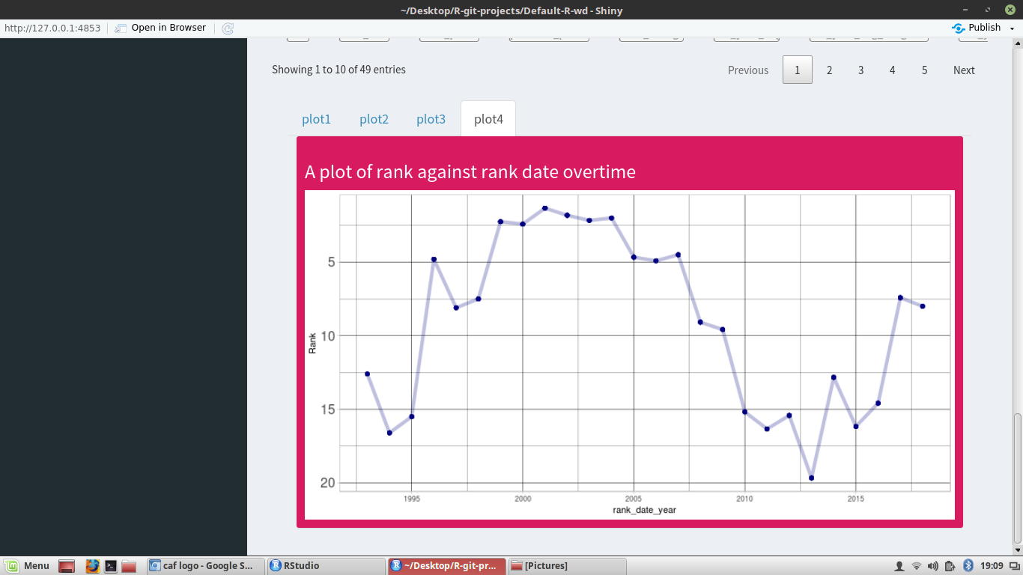

* + 1. Processing

Fig 5.1: Data flow diagram for team performance analysis

* + 1. Data

The FIFA Rankings data set contains the rankings of the member national men’s football teams under FIFA from August 1993 to June 2018. This component uses the rankings from the last four years which is July 2014 to June 2018 for the World Cup Analyzer software.

* 1. SEEDING OF TEAMS
     1. Type

This is an executable task responsible for seeding of teams to take part in the World Cup tournament. Seeding is a process of putting teams in to their groups that they will play their round 1 games at the FIFA World Cup tournament.

* + 1. Purpose

The component pots teams into groups participating in the World Cup tournament according to the FIFA Rankings.

* + 1. Function

It allows the user to select teams which are provided on the website. After the selection, the user submits them using the ‘Seed Teams’ button at the bottom of the page. The teams are seeded and the pots are displayed.

* + 1. Subordinates

For this function to be possible, the FIFA Rankings data set is fundamental as the potting algorithm pots teams according to the rankings. The modules called by this component include; ‘Enter a set of teams’ and ‘Pot Teams’ in that order.

* + 1. Dependencies
* It is assumed that all teams selected by a user qualify for the World Cup.
* A user can select a maximum of 32 teams.
  + 1. Interfaces

When a user opens the home page of the World Cup Analyzer website, they select the ‘Team Seeding’ option from the menu bar. The Team Seeding page has a list of teams that the user can look through and make a selection.

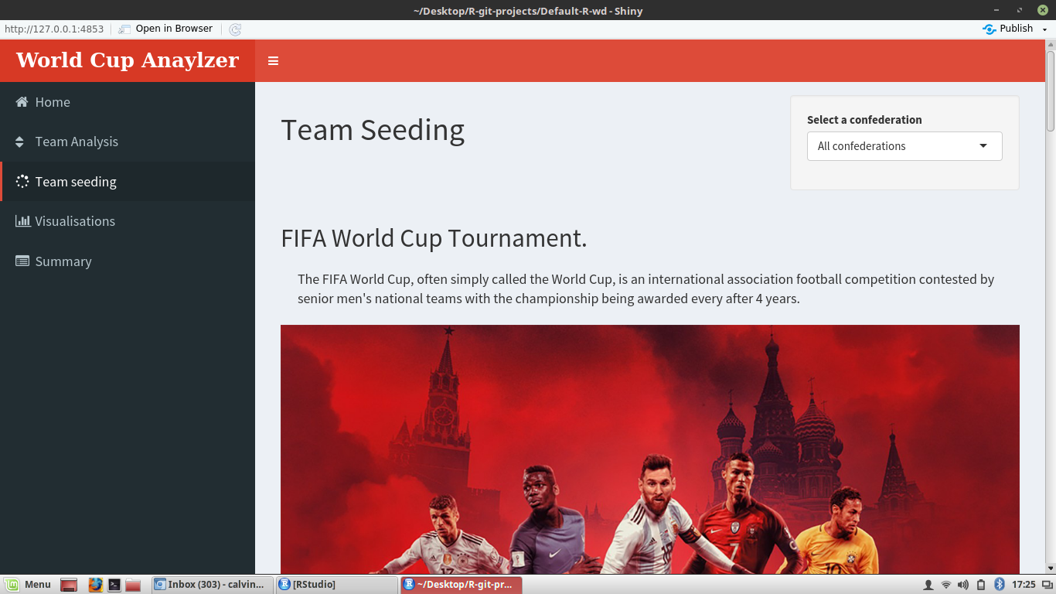

Once they are done, they scroll to the bottom of the page and submit using the ‘Seed Teams’ button.

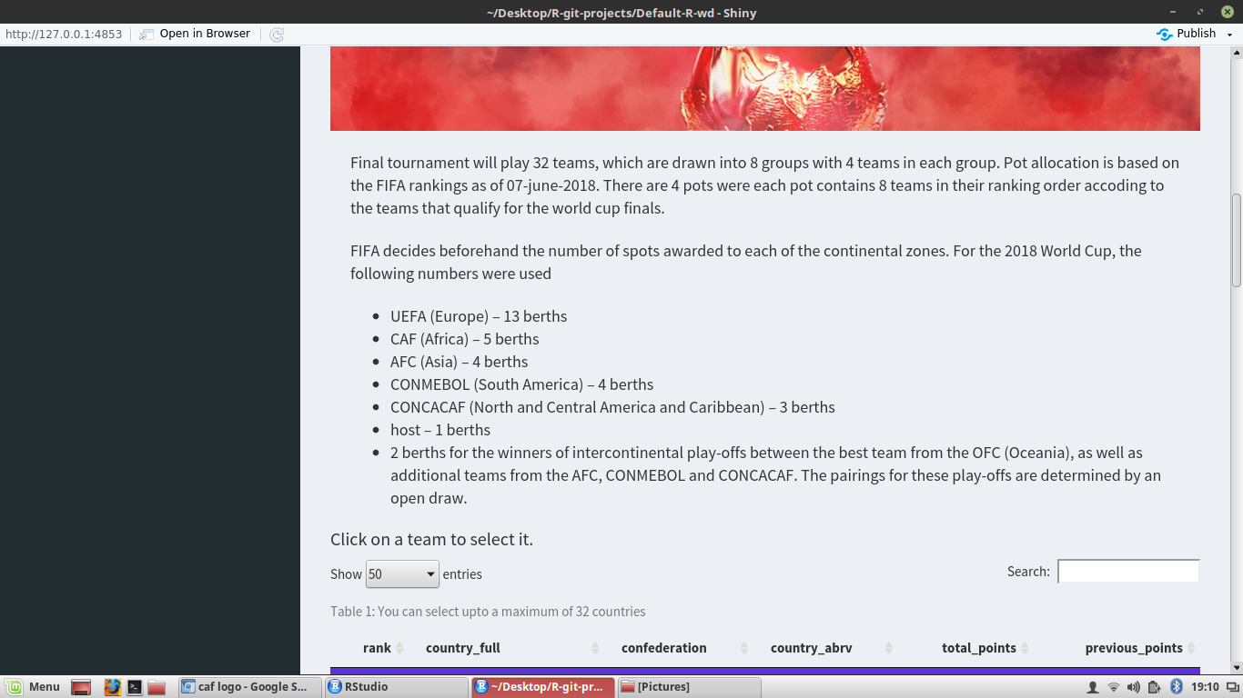

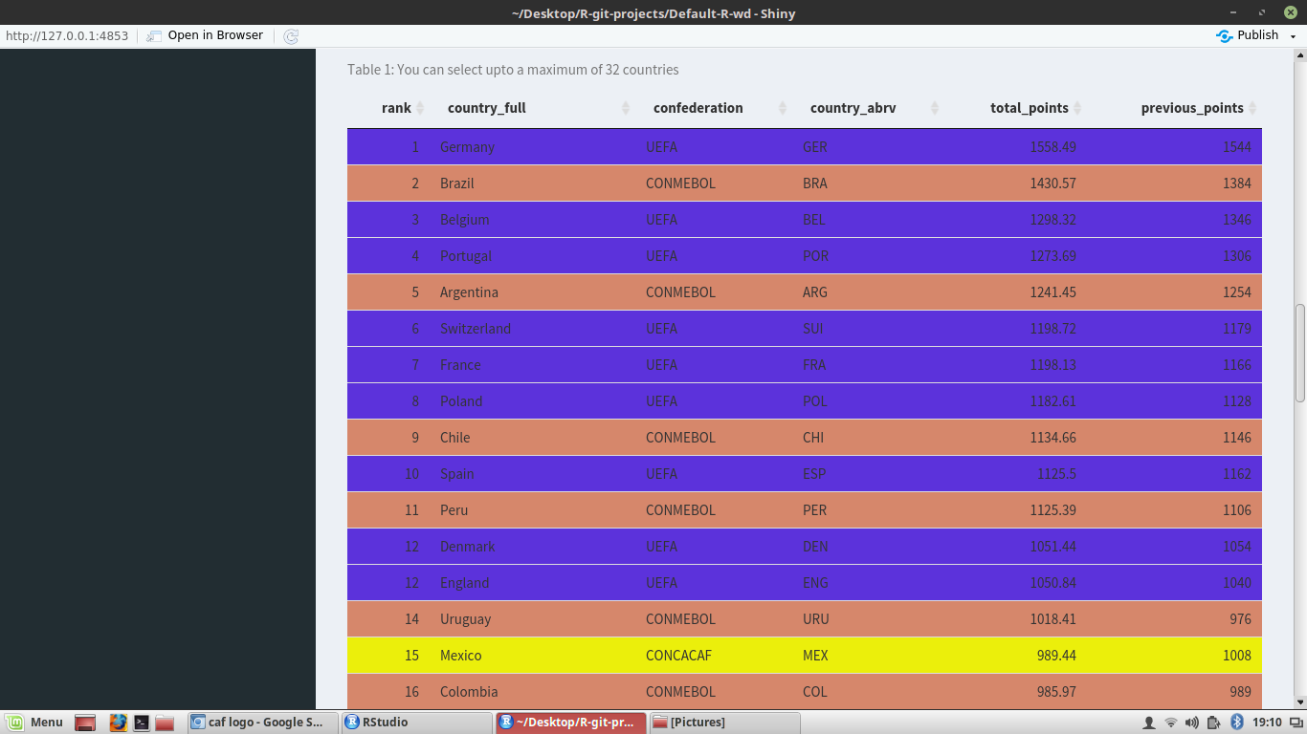

This returns the teams in 8 pots labelled A-G. There are also interfaces of the teams from the confederation and these interfaces describe how the teams from a confederation progress to the world cup finals to guide the user on which teams to select when seeding them basing on the current rankings and how many slots are given to teams of that confederation that qualify for the world cup finals.



The data flow aspects of this task are discussed in section 5.2.7.

* + 1. Processing



Fig 5.2: Level 1 diagram for seeding of teams

* + 1. Data

The FIFA Rankings data set contains the rankings of the member national men’s football teams under FIFA from August 1993 to June 2018. This component uses only the latest ranking which is June 2018 for the World Cup Analyzer software.

* 1. VISUALISATION
     1. Type

Visualisation is an executable subroutine in the World Cup Analyzer software. It relies heavily on the FIFA Rankings data set.

* + 1. Purpose

The visualisations module in the World Cup Analyzer software is used to predict and perform team analyses.

* + 1. Function

When the data set is visualised, Group-6 makes deductions about the data set which are detailed at the end of this section.

* + 1. Subordinates

The visualisations component does not exist/is not necessary without the FIFA Rankings data set. It is called by the Team Performance Analysis module.

* + 1. Interfaces

When a user opens the home page of the World Cup Analyzer website, the user goes to the ‘Visualisations’ page and a summary of our data in form of bar graphs, scatter plots, histograms and lollipop charts.

